1. **Create mariadb db on ec2**

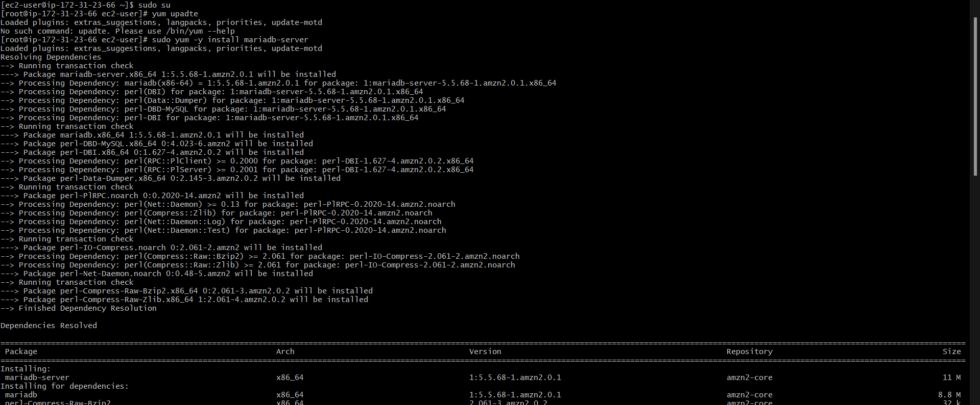

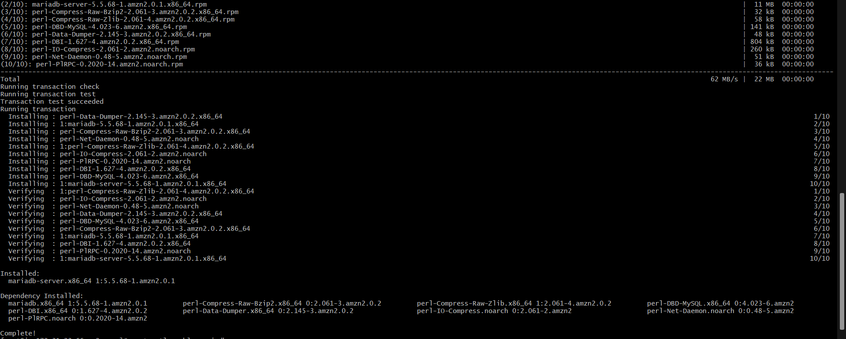

1. **Insert some dummy data**

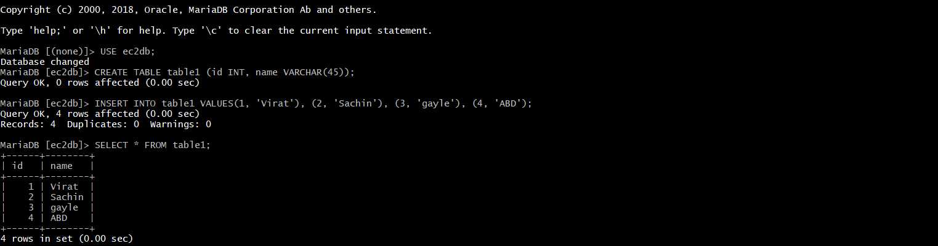

1. **Take the backup of dummy data on ec2**

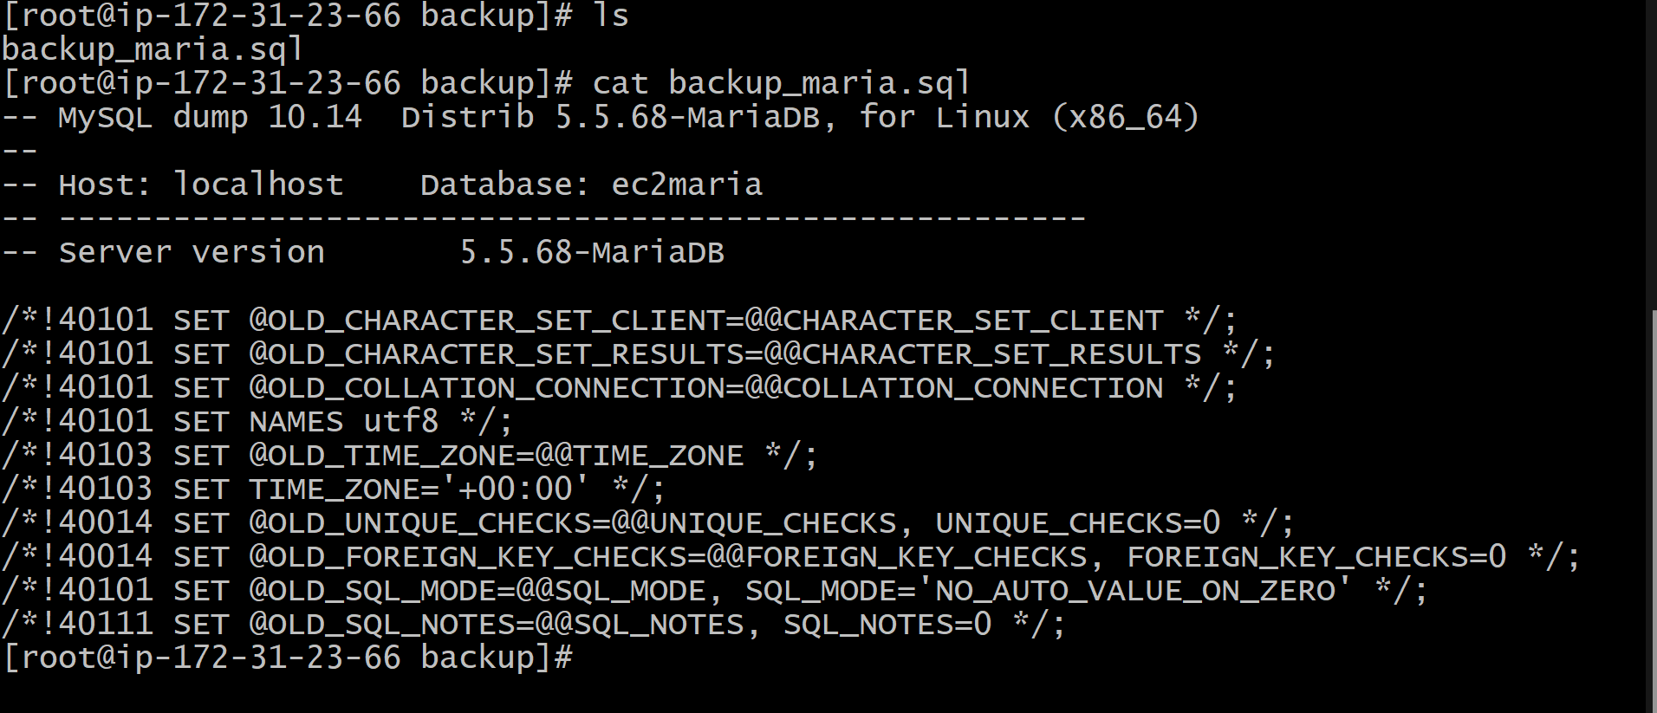

1. **launch Mariadb RDS instance**

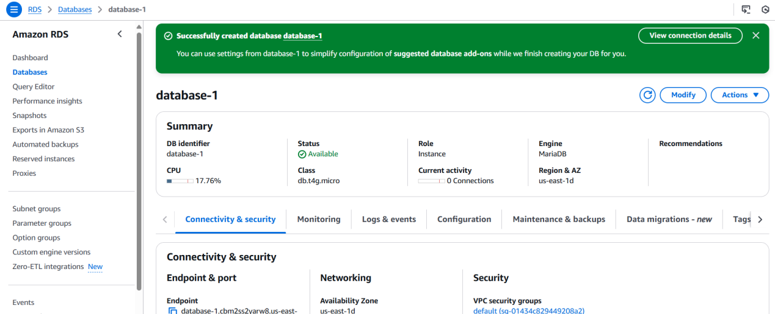

1. **Migrate database from ec2 to RDS**
2. **Install mysql db on ec2**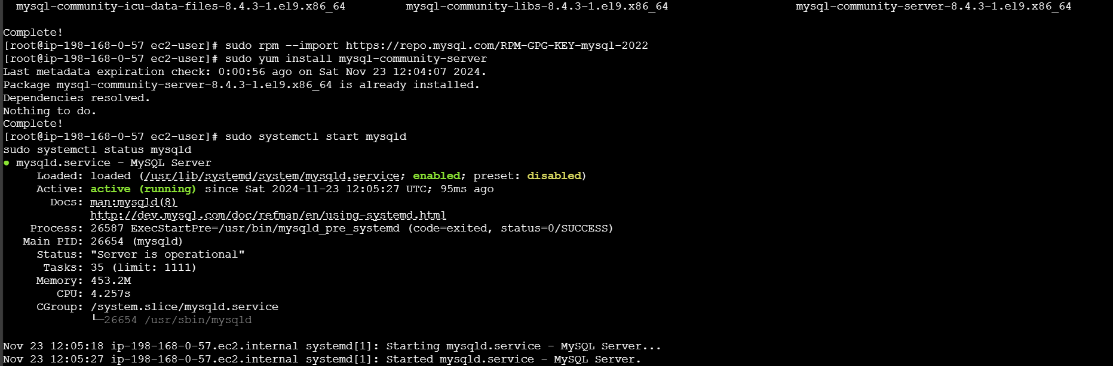

1. **Launch mysql RDS image**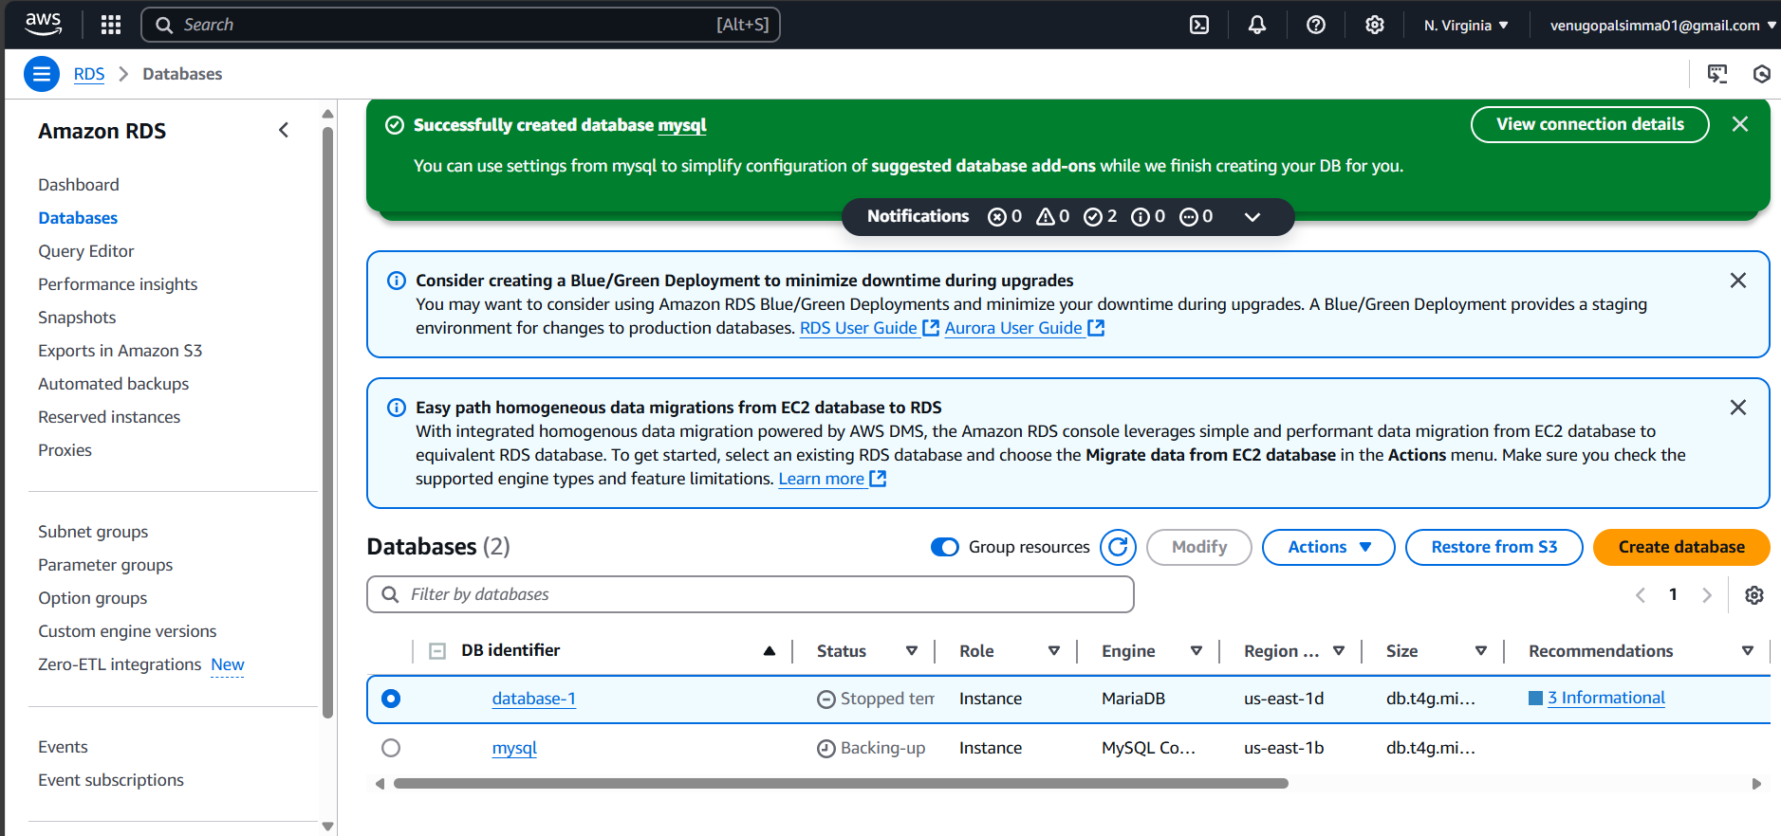

1. **COnfigure multi AZ**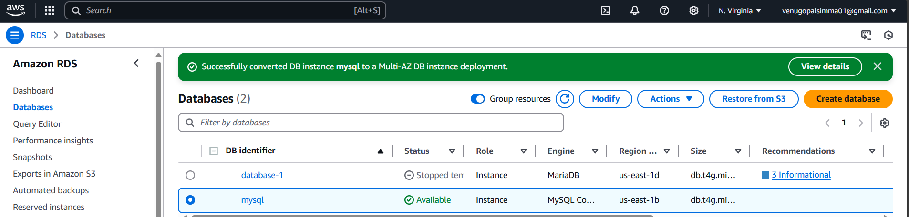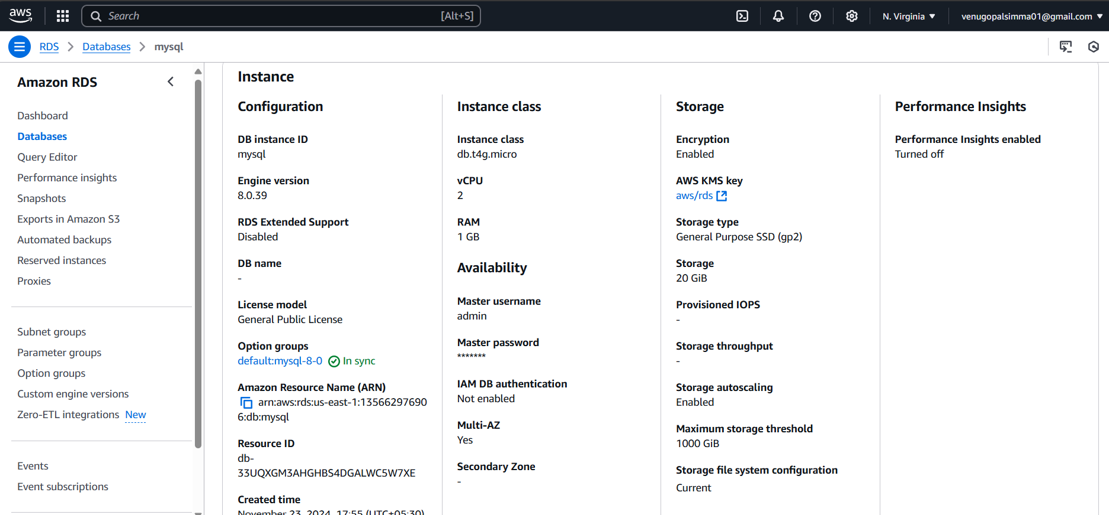
2. **Take Backup of db and restore the DB  
   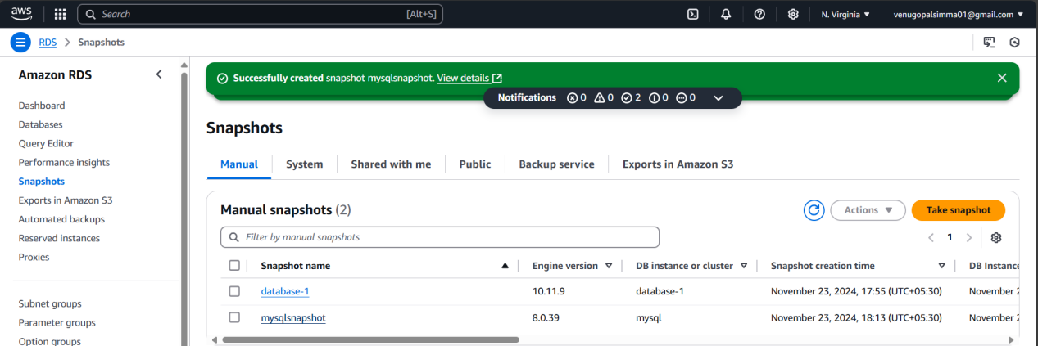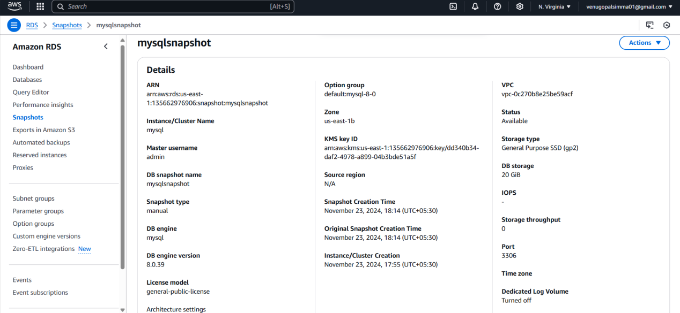**

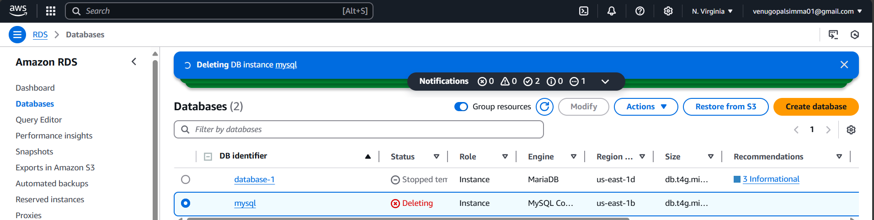

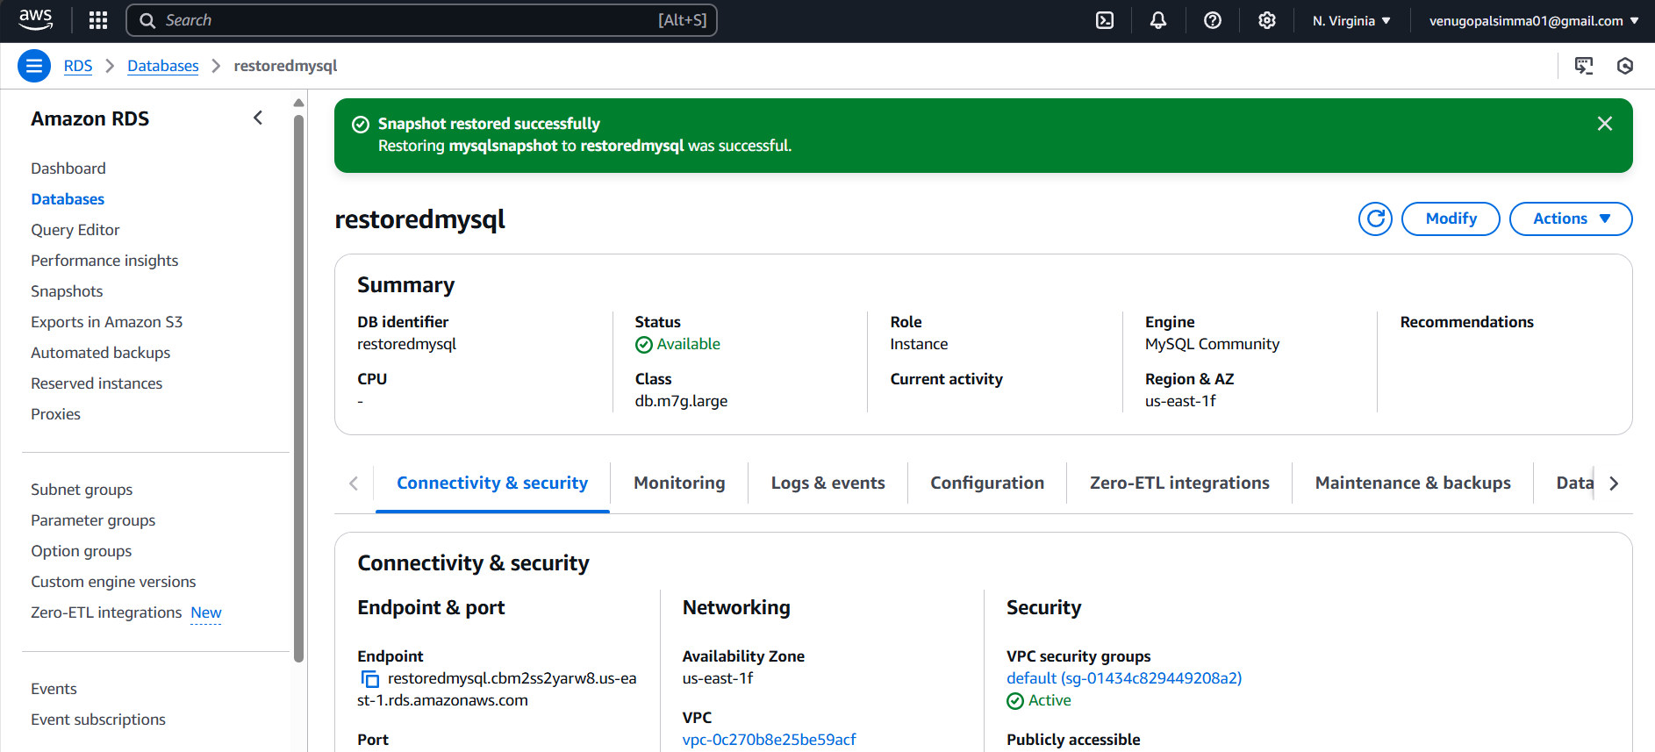

1. **Create ReadReplca**

